COUGAR - OCELOT
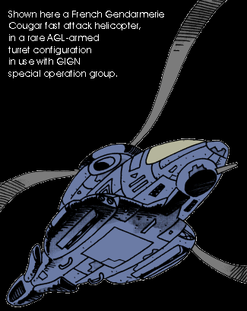
Familly of Fast Attack / Assault Helicopter
This helicopter equips most French Armed Forces fast-reaction units and, in both Cougar and Ocelot versions, is the main Gendarmerie tactical rotorcraft. Designed and built by the Eurocopter division of Esprit Industries, it uses an unusual and advanced propulsion design. Each curved blade is actually hollow and works like a small thruster, expelling gas coming from the main jet turbine engine at the end. The jet exhaust actions the rotor, removing any need for a mechanical rotorhead. As a side benefit, there is no need for a tail rotor, as no torsion momentum is applied to the helo's main body. The system was very difficult to achieve, and only the use of smart materials permitted its realization. Using such a technology offers three main advantages, from a tactical point of view.
First, the use of jet turbine engine and end-blade propulsion enable the helicopter to safely reach very high speeds, while giving it tremendous maneuverability. Second, the smooth and curved design of the rotor and blades greatly enhances the helicopter signature, as in most helicopters the rotor is the main responsible for radar signature. Added to this is the use of a stealth designed cell and RAM coating, to make it one of the stealthiest light helo around. And, third, the helicopter is able to shut down its engine and go on flying in autorotation, gliding almost silently in the air… This last feature is particularly appreciated by Gendarmerie pilots. This advanced design also eliminates most vibrations common to all helicopters, procuring smooth and quiet operation, even while hovering.
Cougar is a fast-attack variant, with military ALAT ("Aviation Légère de l'Armée de Terre", or army aviation) and Gendarmerie versions. Both are armed with the lightweight Esprit Industries LG-30 autocannon on the right side of the fuselage. Four conformal hardpoints usually sports Exocet Exo-Delta missiles (in any mix of version). The internal weapon bay can carry up to four Exocets Exo-Omega missiles, but such a configuration induces a major overload, especially with Army models. Gendarmerie highway patrol units usually carry standard (cheap) AVMs, rocket pods, or other ordnance. Cougar has also a two-passenger compartment. However, the place is cramped on the Army model, prohibiting long-term operational use. It may be used for rescuing the crew of a downed helo, or discreetly inserting an observer/sniper. Doctors have also been flown by Gendarmerie Cougars, in cases of emergency.
Ocelot is a lightly armed assault variant, for the Gendarmerie. The main distinguishing feature is its passenger-carrying capability. It sports a chin mini-turret, and has four conformal hardpoints usually sporting Exocet Exo-Delta missiles (in any mix of version). Ocelot does not have Cougar's internal weapon bay, trading it for a six-man passenger area. Thank to the smooth operation of the aircraft, Gendarmerie regurlarly deploys snipers onboard… All Gendarmerie aircraft have a fully orientable Xenon smart spotlight and PA system under the fuselage.
Puma is a military fast tactical helicopter variant, able to carry a five-man team. This French Army ALAT ("Aviation Légère de l'Armée de Terre", or army aviation) does not have Cougar's internal weapon bay, trading it for a five-man passenger area. While Ocelot is more or less the standard operationnal helo for the Gendarmerie, the Army uses Puma as a special–operations helicopter and thus has a fewer number of these. Gendarmerie's infamous GIGN "Groupe d'Intervention Gendarmerie Nationale" also has a couple of Puma in use.
Griffon is a dedicated variant for RESCO ("Recherche Et Sauvetage de COmbat", or combat search-and-rescue) operations and is operated by the French Air Force ("Armée de l'Air – Forces Aériennes Françaises").
Lynx is the naval version of Ocelot fast tactical helicopter, operated by the French navy ("Marine Nationale", aka "la Royale"). The navy has three Lynx squadrons earmarked for maritime patrol and anti-submarine warfare duties, and two earmarked for naval SAR (Search-and-Rescue) duties.

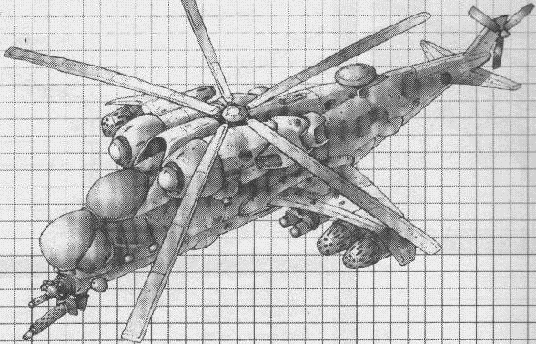
Dassault SIROCCO
(Heavy) Special Operations Helicopter

Sirocco : hot wind coming from the south, mainly at night.
Early 2055, Aztlán/Aztechnology military forces operating in the Yucatán peninsula expressed the need for an helicopter designed for special operations in hostile territory. Aztechnology forwarded the contract to its french subsidiary Dassault, in part due to Dassault expertise in aeronautics, and also because Aztechnology didn’t want to divert to many ressources for such a small-scale project. Two years later, the resulting aircraft entered operations in Yucatán, and proved even more successful than expected. Aztechnology then engaged them in Desert Wars ’58, where they showed superior survivability and firepower.
The design of the Sirocco helicopter is similar to the late XXth century Mi-24 "Hind" soviet helicopter. The flight crew sit in tandem in a dedicated compartment in front, accessed by armored hatches, and the special operation team is carried in the rear compartment, which has two sliding doors and a rear loading ramp. The cargo area is large enough to carry ten or so SF soldiers and their assorted gear, or to receive a Scorpio special operation vehicle and its crew, though other vehicles can be carried.
Yep. An attack helo with cargo capability and a rear loading ramp, able to carry a fast-strike all terrain vehicle and its crew. A bit high-profile for a shadowrunning team though. This is really for spec-ops, through and through. Forget about it chummer, and leave this monster to the military.
Argent
May I bother someone in daring asking what a Scorpio-thing is ?
Ignorant and curious
Figure a dune buggy sporting HMG, assault cannon, and two or three Spec Op lads. You got the idea.
Helpful Merc <My Pleasure>
The engineers who designed it expected the Sirocco to be fired upon; the helicopter is thus heavily armored, and is able to survive all but the most serious damage. Its extra-light alloy composite armor reaches levels previously reserved to T-birds, and its multiplexed Contingency Manoeuver Control systems allow it to fly back home when many other of its kind would crash. Some helicopters operating in Yucatán reportedly came back to their base after receiving three or four direct SAM hits.
The hell they built it strong! I saw it myself. I was in Aztlán for biz, and I saw some kind of monster helo —I didn’t know what it was at the time— taking three Dagger manpack SAM hits. And continuing to fly and raise hell as if nothing happened. Well, actually a bit angry, as it obliterated the area where the SAMs came from. For no result, as the rebels remote-fired the missiles.
Captain’ SAM
Survival of the helicopter and the Special Operation team it carries is also achieved by way of quite a massive firepower. The helicopter sports a small chin turret, usually mounting a rotary assault cannon (some helicopters were reported equipped with a heavy vehicle laser), and one mini turret (usually sporting miniguns) on each side at the rear. Each door and the rear loading ramp are equipped with firing positions, and usually sport a HMG or AGL. Each gun position is smartlink-II compatible. These weapons have to be operated by the Spec-Ops team or gunners, though.
Aztlán SOP is to bring in gunners… Tsahal doesn’t even bother sometimes with carrying troops. Just the gunners, heavier weapons —autocannons rather than HMGs— and LOTS of ammo… They call it "border patrol" duty.
Euro Merc
An underbelly drone rack provides storage for one or two small drones, used for scouting, electronic reconnaissance or target designation. A video monitor and intercom speaker in the rear area allows the Spec-Ops team to be up-to-date with target recon.
Yeah, I know what you’re thinking about this "non-combat drones only" stuff. Actually, Sirocco helicopters does not need to carry fire support drones, as the helicopter itself is better suited for this role.
Euro Merc
Stubby wings situated each side of the fuselage offer a total of six 300-kg hardpoints for gun pods, bombs, rockets, missiles or droppable fuel tanks, and two 150-kg hardpoints, mounting generally small AAMs or ARMs.
Ah! Gun pods. Don’t ever, EVER, despise them. I saw an old and genuine ex-russian Hind, back in ’24, with six autocannon gun pods, plus its own twin 30mm and one 20mm by each door. With one tracer ammo for ten real bullets, it was like a rain of fire…
Old-timer
The helicopter can be equipped with a telescopic air refuelling boom, allowing a nearly unlimited range or idle time over the operational area.
Versions differ mainly by their electronics suite. However, all systems can be upgraded following customer’s whishes (and financial ressources) and customer-provided systems can be integrated by Dassault technicians. Provisions were made in load capacity and cargo space for further upgrade (even on SOTA Aztlán models).
Yeah, but at the expense of military payload or carried troops.
Gunny
The Sirocco low signature is acheived by an overall stealth design, a RAM coating, and a short-term electric drive, derived from the infamous Aguilar combat helicopter. On top of that is a ruthenium polymer skin assuring a near-perfect camouflage in the visible spectrum.
Most Export models have only a standard two-rigger crew, a pilot and a systems operator. Both can operate the aircraft weapons or drones, depending on the other rigger’s workload. However Aztlán and a few Export models incorporate a third, magically active, crewman. The magician lies in a special anti-G compartment, without windows and accessed by the rear cargo area, which replaces a fuel tank. A fiber-optic network and special optical goggles gives him full 360° vision in all three dimensions around the aircraft, allowing him to cast spells, direct elementals or give spell defense.
I was in Yucatán last year —don't ask—, and I saw one of these in action. Or didn’t, actually. All I saw was dust kicked by the rotor blast, and tan-clad Jaguar warriors jumping literally out of the blue, all the while hearing nothing! Impressive and scary.
New Dawn Mercenary <been there, done that>
To date, the aircraft equip Aztechnology Jaguar Guard, and a few selected elite units from the Aztlán and Aztechnology military. The Dassault export version as been sold to various country and mercenary organizations, including Israel.
Israeli spec-op slags nickname it "flying Merkava" in reference to the late XXth century Merkava MBT who proved to be able to be hit more than twenty times (!!!) by ATGMs and keep kicking ass.
Euro Merc

Yakovlev
( Yamatetsu Aerospace )
YAK-77 "Komet"
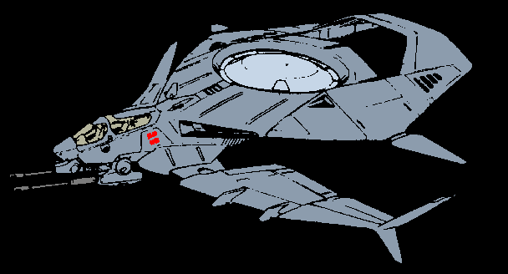
Combat Aerodyne

Early 2058, Yamatetsu acquired the remnants (names and licence rights, mainly) of formerly prestigious Russian aircraft manufacturer Yakovlev. Since then, Yamatetsu has shown the ambition to build its own aerospace structure, and this is the first produce of the new aerospace firm.
Russian-designed and built with Japanese high-exigence for quality in the new Vladivostok plant, Komet inaugures a new kind of aircraft. Half-plane, half-helicopter, this aerodyne offers true VTOL operations and hovering flight if needed, while keeping the high speed, ruggedness and survivability of an airplane.
Vertical lift is provided by a fenestron rotor turbine in the fuselage, and twin turbine engines provide horizontal thrust. Additional lift is provided by the wings at speeds over 135 and helps lessen overall fuel consumption.
Komet exists in three main variants : YAK-77 Komet security variant, YAK-78 Komet military variant, and YAK-79 Krystal electronic warfare variant. Naval variants also exist. Each variant is in use with Yamatetsu military and security forces, and has been evaluated by Russian naval forces.
YAK-77 "Komet" security variant
Handling | Speed | Accel | B/A | Sig | Autonav | Sensor | Cargo | Load
3 | 800 | 42 | 4/8 | 4 | 3 | 7 | ** | **
Chassis : Small Airplane
Power plant (1) : Utility helo
Power plant (2) : Twin-Engine
DP : 2,024; Mark-up factor : 3.5 x 3.0
Total CF capacity : 40; load capacity : 2,500 kg
Cost : 4,681,200¥
Seating : 2 buckets (ejection) seats
Access : 1+1h
Fuel : 2,500 (liters)
Economy : 0.25 km per liter
Flight profile : VTOL operations. May also operates as a VSTOL airplane.
** Cargo : 14 CF available for system upgrades
** Load : 1,200 kg for weapons. 278 kg available for system upgrades
Electronics suite :
- Sensors : Security III (7)
- ECM : Security II (6)
- ECCM : Security II (6)
- Electronic Deception : Security II (2)
Combat Electronics :
- Collins (Federated-Boeing Avionics) "Black-Eagle" tactical computer
- Collins (Federated-Boeing Avionics) "Eagle Eye" threat warning system
- Tracor ALE-50 chaff/flares/decoy launcher (holds up to 40 decoys)
- Collins communications system (Level 14)
- Electronic ports (x2)
Other Features :
- Datajack Port (x2), Rigger “Black Box” Adaptation, Secondary controls, APPS (x2), Ejection seat (x2), EnviroSeal (gas), EnviroSeal (overpressurization) with life support generator.
- Structural Agility (1) -adds +1 to Pilot Reaction-, Contingency Manoeuver Controls (3).
- Improved Handling (2)***, Improved Speed***, Improved Acceleration***, Improved Economy***. Improved Cargo Space***, Improved Load Capacity***, Reduced Fuel Capacity***. Improved Signature (Stealth Design) level 1***. Fly-By-Light system (1)***. Standard Armor (8)***.
*** Already Factored In
Armament :
- Twin (linked) single-tube KPV 14.5mm heavy machineguns with 2x1,500 rounds (dual-feed) each. Each weapon is mounted on an external Hardpoint with Gunnery Recoil Adjusters (6).
Weapons are not independent and both shoot at same target (roll dice only once, calculate damage for BOTH if a hit is scored).
- 4 "dry" 300 kg hardpoints for missiles or other ordnance.

